Aim: To install AngularJS and implement a basic AngularJS application that demonstrates the following core concepts:
- Controllers
- Directives
- Services
- Data Binding
- MVC Architecture

Q1. What is AngularJS?
A structural JavaScript framework for dynamic web apps, allowing HTML extension with custom attributes. It uses two-way data binding and the MVC pattern.

Q2. What is MVC Architecture in AngularJS?
- Model: Data ($scope variables)
- View: HTML templates (what users see)
- Controller: JavaScript functions managing data and logic

Example:
// Model & Controller
app.controller('UserController', function($scope) {
$scope.name = "John"; // Model
$scope.sayHello = function() { // Logic
alert("Hello " + $scope.name);
};
});

<!-- View -->
<div ng-controller="UserController">
<input ng-model="name">
<button ng-click="sayHello()">Greet</button>
</div>

Q3. How $scope is Automatically Injected?
Through Dependency Injection - AngularJS reads function parameters by name and provides matching services:
// Angular sees "$scope" and injects the Scope object
app.controller('MyCtrl', function($scope) {
// $scope automatically available
});

Q4. List and give use of directives
Directive | Purpose | Example
ng-app | Auto-bootstraps AngularJS app | `<html ng-app="myApp">`
ng-controller | Attaches controller to view | `<div ng-controller="MyCtrl">`
ng-model | Two-way data binding | `<input ng-model="username">`
ng-repeat | Loops through arrays | `<li ng-repeat="item in items">`
ng-show | Shows element if true | `<div ng-show="isVisible">`
ng-submit | Handles form submission | `<form ng-submit="save()">`

Q4. Create a program to demonstrate a login form
(index.html) Code:
<!doctype html>

<html ng-app="studentApp">
<head>
<title>Student Login</title>

<link rel="stylesheet" href="style.css" />

<script src="https://ajax.googleapis.com/ajax/libs/angularjs/1.8.2/angular.min.js"></script>

<script src="app.js"></script>

<script src="loginController.js"></script>
</head>

<body ng-controller="LoginController">
<div class="login-container">
<h2>Student Login</h2>

<form ng-submit="login()">
<div class="form-group">
<label>Username:</label>

<input
type="text"
ng-model="username"
placeholder="Enter username"
autofocus
/>
</div>

<div class="form-group">
<label>Password:</label>

<input
type="password"
ng-model="password"
placeholder="Enter password"
/>
</div>

<div class="error" ng-show="errorMessage">
{{ errorMessage }}
</div>

<div class="button-group">
<button type="submit">Login</button>

<button type="button" ng-click="resetForm()">Reset</button>
</div>
</form>

</div>
</body>
</html>

(loginController.js) Code:
app.controller("LoginController", function ($scope, $window) {
var validStudent = {
username: "abc",

password: "123",
};

$scope.login = function () {
if (!$scope.username || !$scope.password) {
$scope.errorMessage = "Please enter both username and password";

return;
}

if (
$scope.username === validStudent.username &&
$scope.password === validStudent.password
) {
localStorage.setItem("isLoggedIn", "true");

localStorage.setItem("username", $scope.username);

$window.location.href = "welcome.html";
} else {
$scope.errorMessage = "Invalid username or password";

$scope.password = "";
}
};

$scope.resetForm = function () {
$scope.username = "";

$scope.password = "";

$scope.errorMessage = "";
};
});

Ouput:
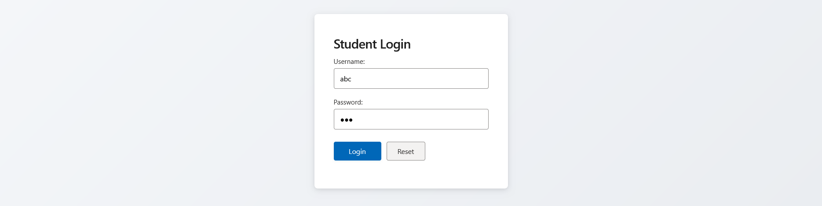

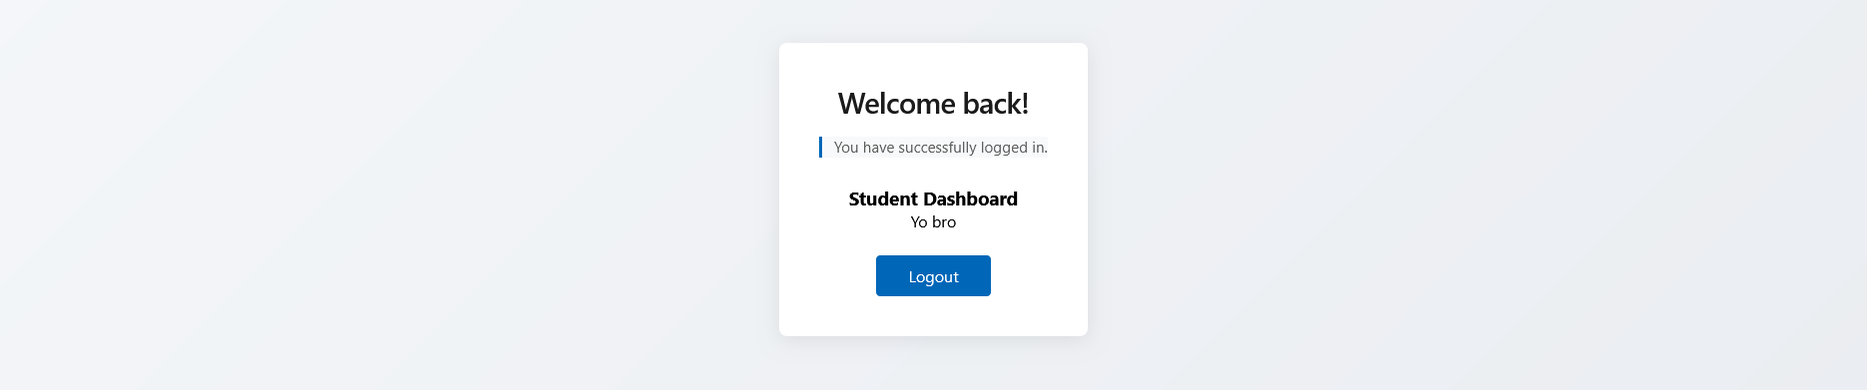
Conclusion:
In this experiment, we successfully installed AngularJS & implemented of Basic AngularJS Application.

